Amazon AWS Virtual Machine Setup:

Step 1:

Go to <https://aws.amazon.com/console>

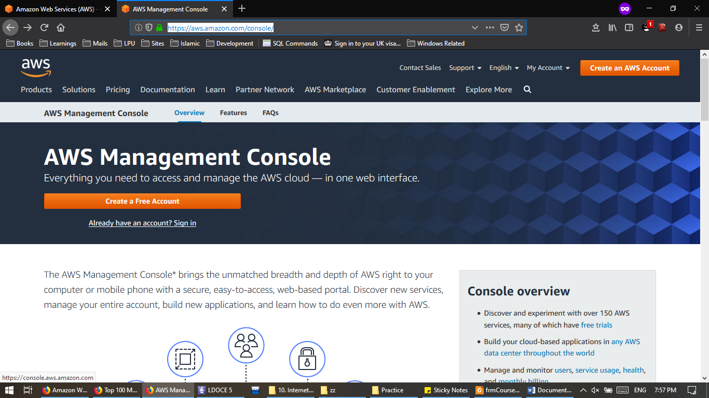Click on Already have an account? Sign in.

Step 3:

Sign into your Amazon AWS account.

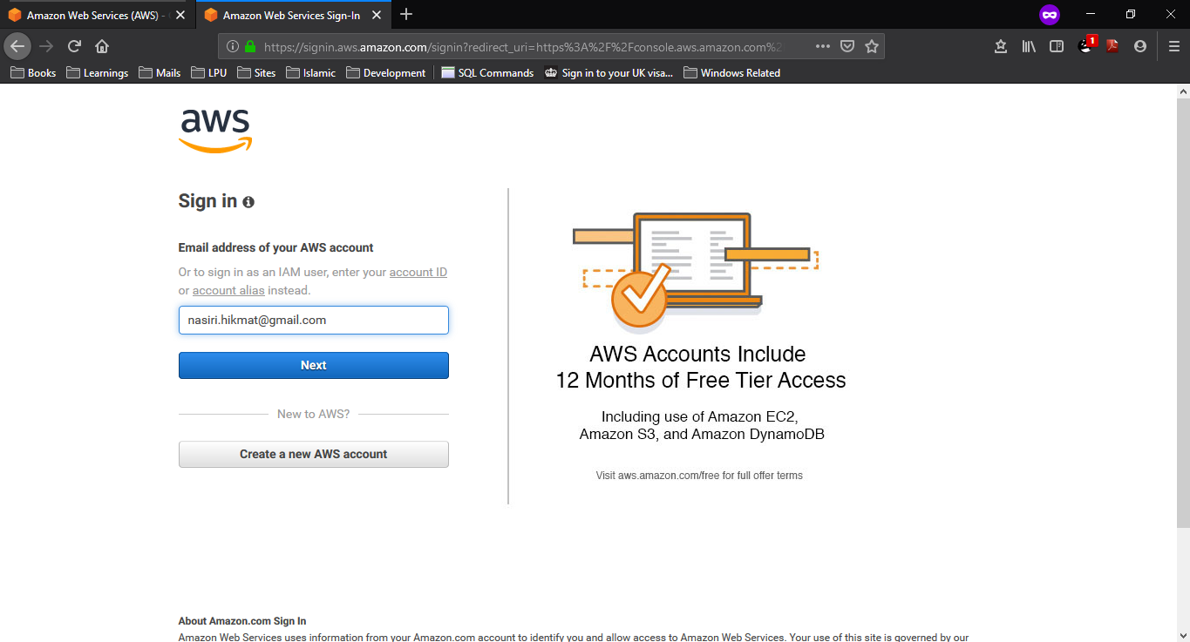a

Step 3:

Enter the Password for Amazon AWS Account.

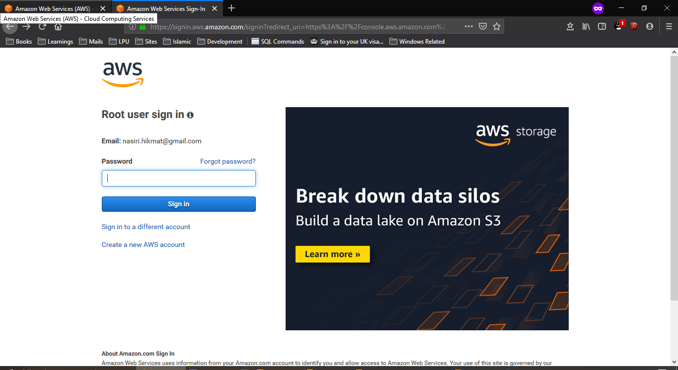

Step 4:

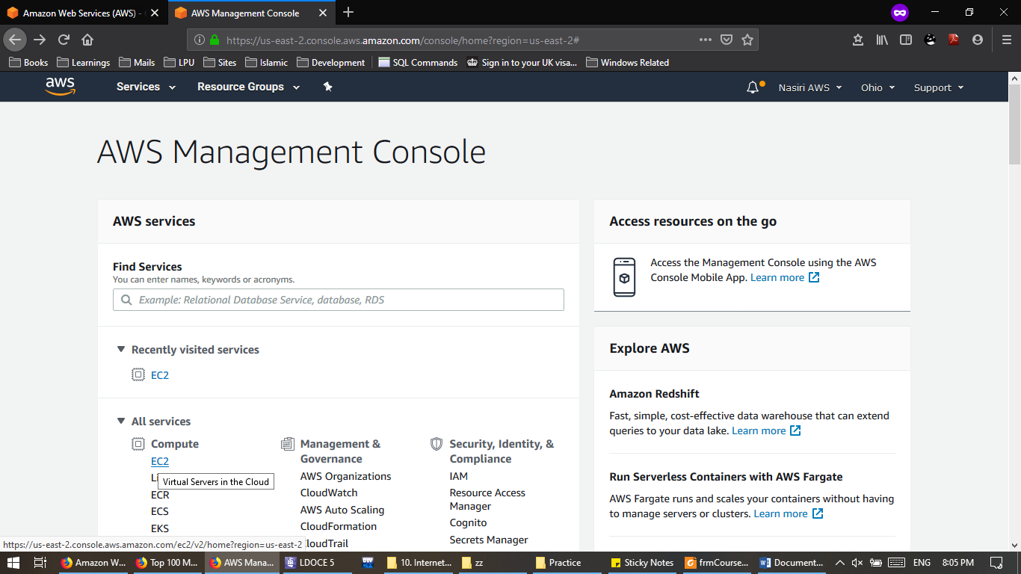On Console Page Click on EC2.

Step 5:

On EC2 Dashboard Click on Launch Instance.

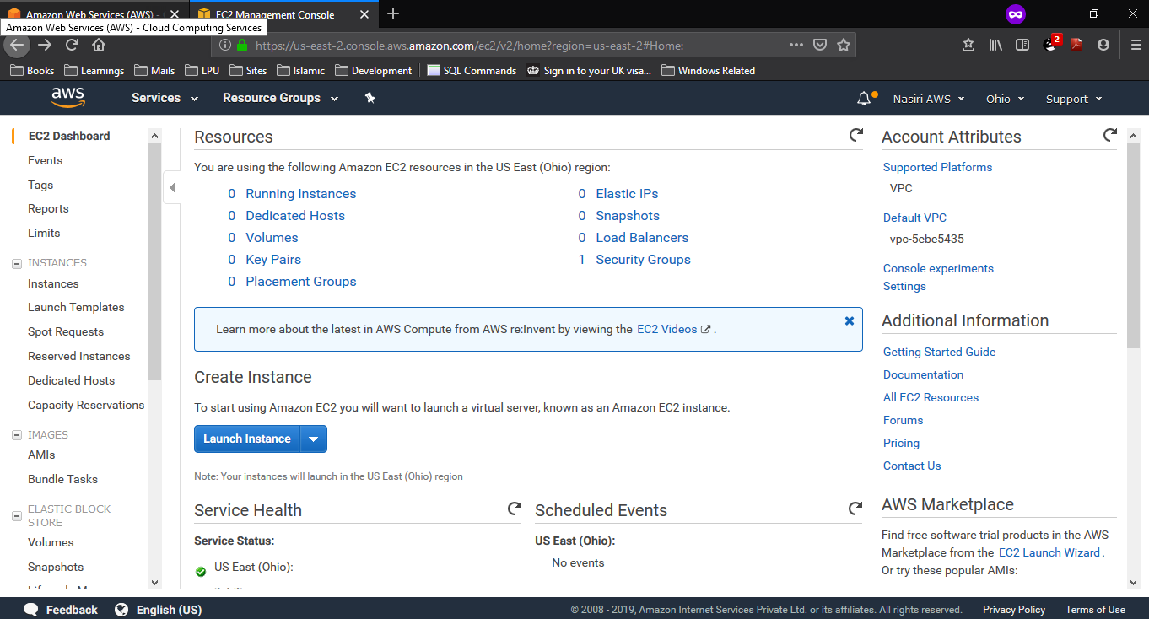

Step 6:

Select the Amazon Machine Image.

We will go for Ubuntu Server 18.04

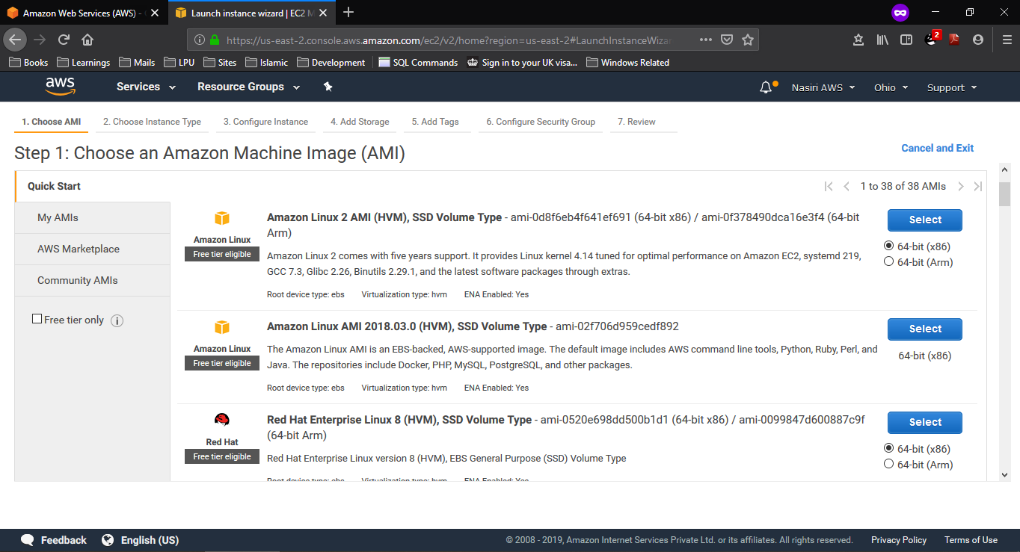

Step 7:

Choose an Instance Type Go for free Instance.

Next: Configure Instance Details.

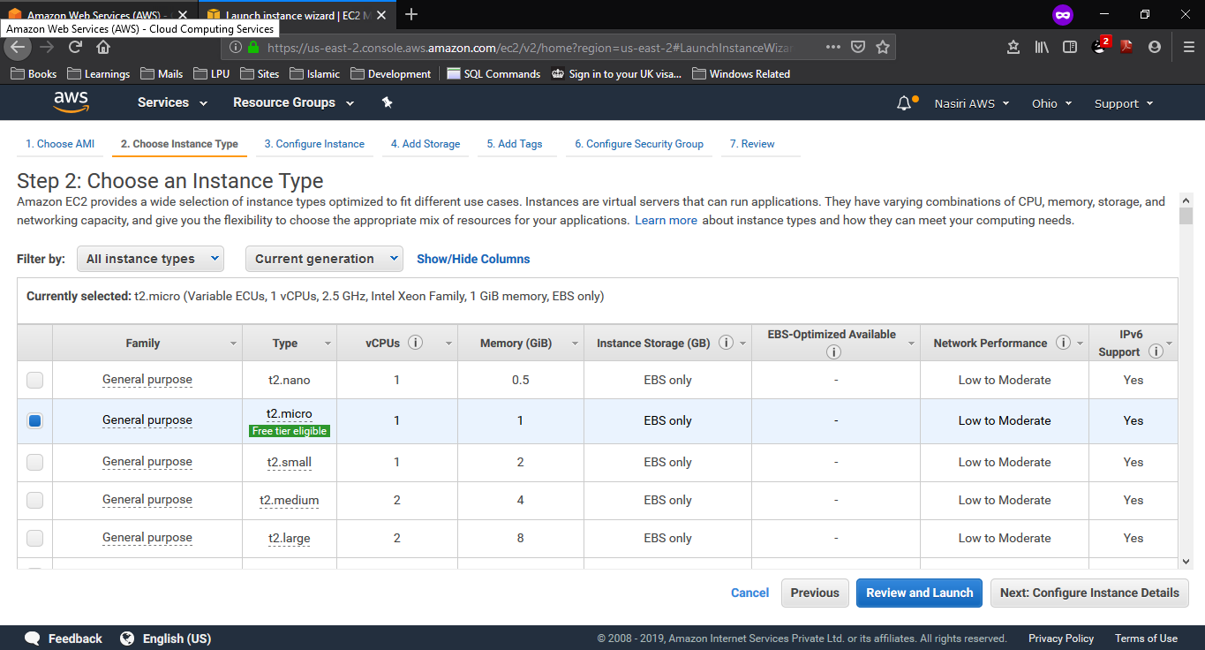

Step 8:

Configure Instance Details.

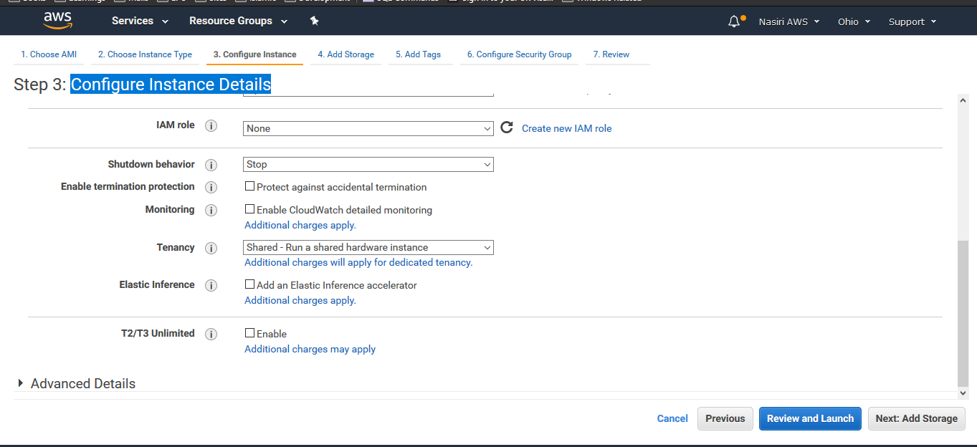

Step 9:

Add Storage.

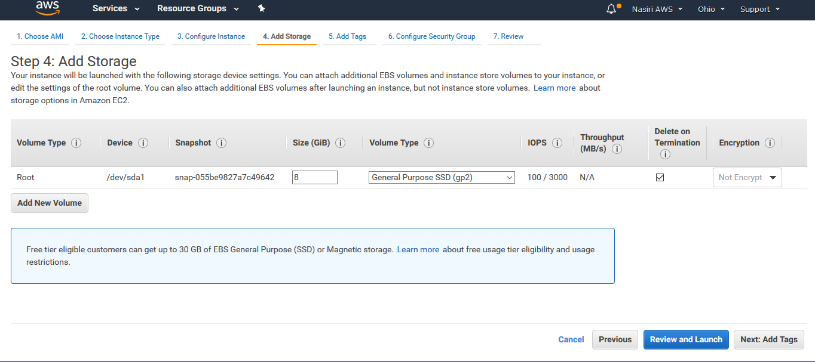

Step 10:

Ignore the Add Tags Page.

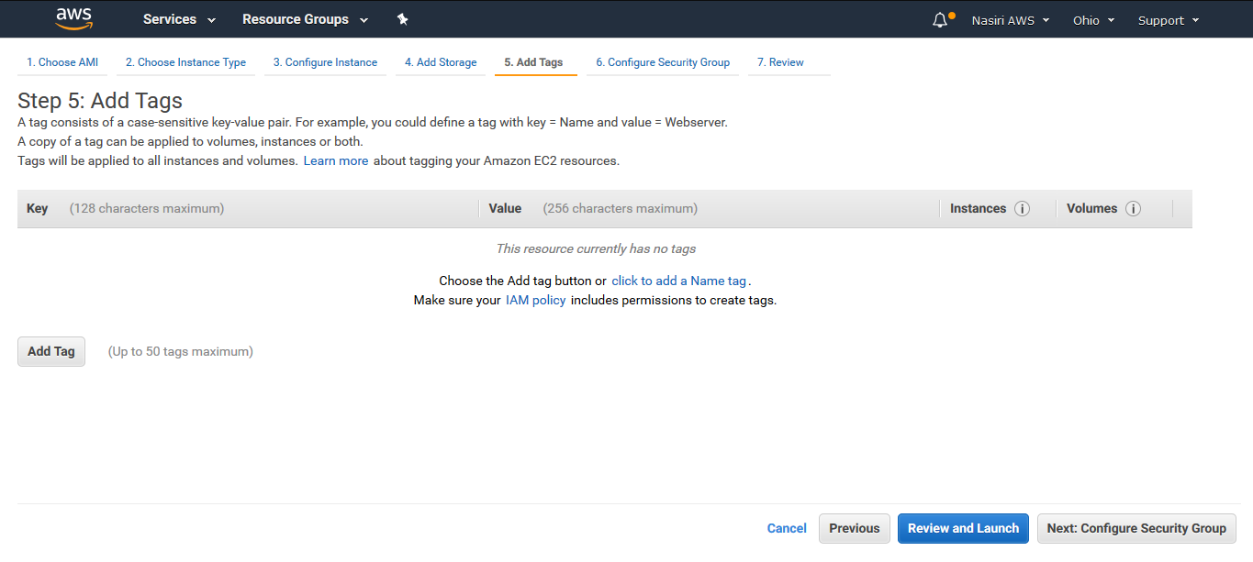

Step 11:

Configure Security Group go for RDP.

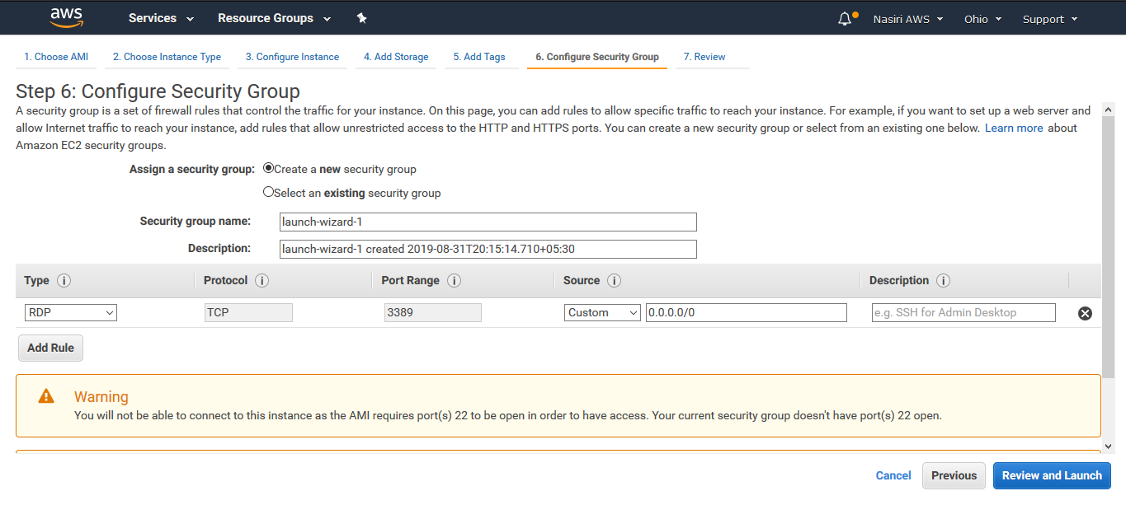Review and Launch

Step 12:

Launch.

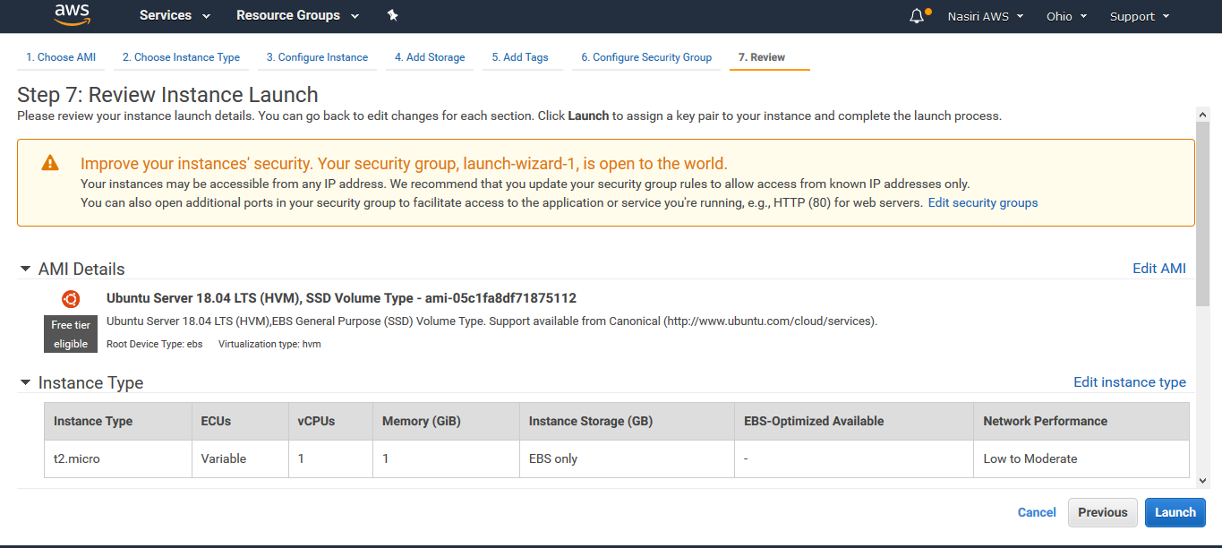

Step 12:

Create a new key pair type the pair name.

Download the Key Pair.

Launch Instances.

Click On View Instances.

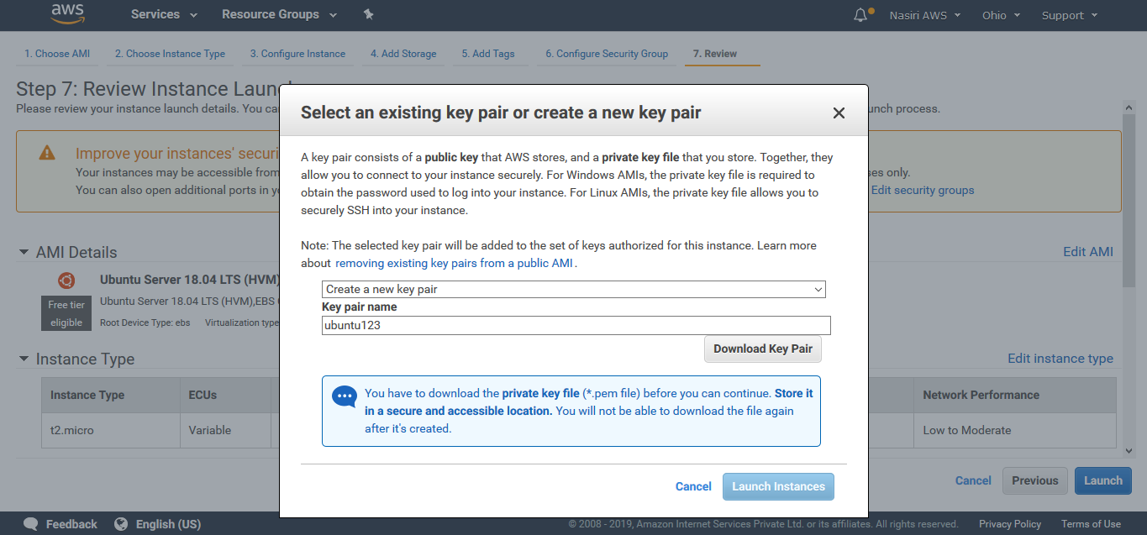

**Log in to Virtual Machine**

Step 1:

On Instances Page Click On Connect Button.

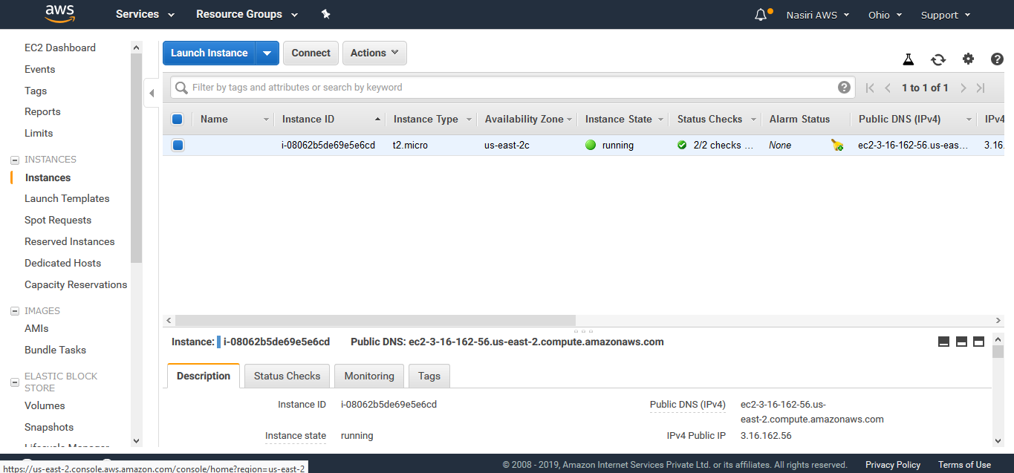

Step 2:

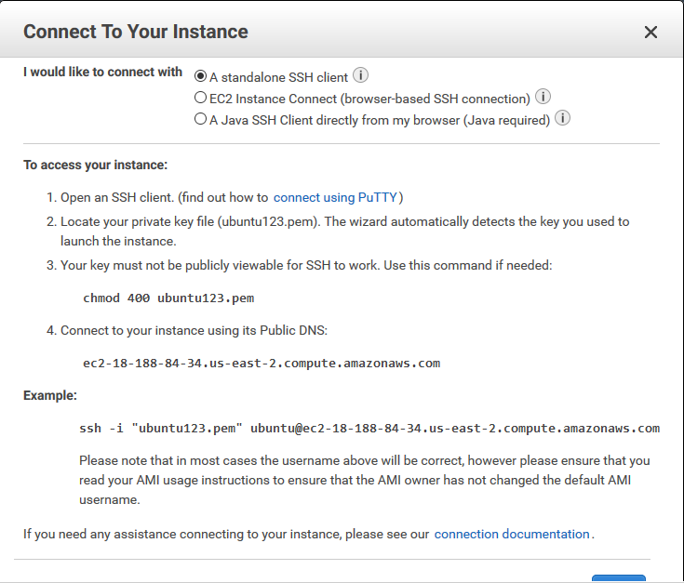Connect to your instance using SSH command

Step 3:  
Connecting through terminal.

